Monetary Policy Strategies for the ECB*

Christopher Erceg, Zoltan Jakab, Jesper Lindé

The views expressed are solely those of the authors and should
not be interpreted as reflecting the views of the IMF or any
other person associated with the IMF

* Preliminary – do not circulate without authors permission
What We Do
● We consider the consequences of low steady state real and nominal rates for the EA economy, and different monetary policy strategies to deal with it.
● Start out by studying effects of a ZLB in an estimated workhorse macro model of the EA given current policy regime.
- Long-sample artificial data generated through stochastic simulations (unconditional distributions).
- Forecast distributions given state 2020Q3 (Conditional distributions).
● Second, we use the model to analyze how UMP can improve the unconditional and conditional distributions:
- NIRP (allowing for the possibility that ELB is negative)
- Forward guidance (FG)/“Lower for longer”/Make-up policy
- Large Scale Asset purchases (LSAPs).
What We Do (Cont.)
● Next, we use the estimated model to analyze the merits of alternative monetary policy regimes:
- Symmetric target instead of current asymmetric regime
- Symmetric rule but lower inflation target (1.5 percent)
- Average inflation/price level targeting
- Target band for inflation
● Macroeconomic model: Use variation of workhorse Smets and Wouters (2007, AER) model to do the analysis
- Estimate model on Euro Area data (1985Q1-2019Q4).
● Address the FG puzzle by allowing for deviations from rational expectations (RE) following Gabaix’s (2019) behavioral approach.
- BR for households in baseline model, also for firms and labor unions in robustness analysis.
- Compare findings with RE model throughout the paper.
Contribution to Existing Literature
● We add to the papers by Bernanke et al. (2019), Coenen et al (2019), and Andrade et al. (2020) by:
- Considering an estimated DSGE model which addresses the forward guidance puzzle.
- Considering a model environment with a low steady state real rate substantially below the potential growth rate of the economy.
● First to assess the macroeconomic implications of an asymmetric target for the ECB in a low interest rate environment:
- The GC in October 1998 defined price stability as HICP yoy inflation of under 2% and added that price stability “was to be maintained over the medium term”.
- Strategy confirmed in May 2003 following a thorough evaluation of the ECB's monetary policy strategy: “in the pursuit of price stability, it aims to maintain inflation rates below, but close to, 2% over the medium term”.
- ECB has recently taken steps toward symmetry (e.g., July 25th 2019 MP statement), but this has not been codified in a subsequent Strategy Review.
Some Key Findings
● Our unconditional simulation results suggest that:
- UMP cannot fully offset adverse effects of an asymmetric target in a low rate environment.
- Sizeable output gains (higher mean and lower std) of moving away from asymmetric to a symmetric target.
- AIT/PLT strategies associated with increased output volatility in our model with flat Phillips curve and prominent role for cost-push shocks.
● Our conditional simulation results suggest that:
- Full set of UMP tools (NIRP, FG and LSAPs) needed to improve current outlook.
- Important to drop output growth response in rule in large recessions (focus more on inflation and output gap/unemployment).
- Fully credible AIT/PLT strategies stimulate economic activity and nudge medium-term inflation closer to target.
Remainder of Presentation
● Outline and key properties of estimated model.
● Benefits of UMP:
- Effects of unconditional distributions.
- Effects on conditional distributions.
● Benefits of new frameworks
- Effects of unconditional distributions.
- Effects on conditional distributions.
● Robustness analysis.
● Conclusions and future work.

Outline of Benchmark Model
• Smets and Wouters (2007) model which is a multi-shock variant of the CEE (2005) model designed to have a realistic MTM:
- Sticky prices and wages due to Calvo-style frictions (monopolistic competition).
- Real Rigidities (Habit formation and investment adjustment costs).
- Variable capital utilization, fixed costs of production.
• Seven shocks: technology (a), investment-specific (q), risk-premium (b), government spending (g), price (p) and wage markups (w), and monetary policy (m).
- Out of these seven shocks, the first four affect flex-price-wage (potential) allocations.

Outline of Benchmark Model (Cont.)
• Modelling of deviations from RE follows the behavioral approach in Gabaix (2019):
$E_{t}^{BR}X_{t+1}=φE_{t}X_{t+1}$.
• Baseline BR model features deviations for RE for households; maintain RE assumption for firms and labor unions.
- Estimate household behavioral parameter $φ^{h}$ to 0.95. Gabaix (2019) use 0.85.
- Relax RE assumption for firms and labor unions and consider full BR model in robustness analysis ($φ^{f}$ estimated to be 0.95 as well).
- Steady state unaffected.
• Posterior odds strongly favors behavioral model relative to RE model conditional on SS with low real rate (0.6 p.p. annualized).
- LML for BR model (-472.6) > LML for RE model (-492.8)
Key Properties of Estimated Model
• Assess behavioral model properties in some detail, relating to variant with standard RE assumption.
• First, study Phillips curves and variance decompositions.
• Second, study impulses to key shocks in model.
• Third, study potency of FG in model (not shown here, discussed in paper).

Key Properties of Model: Variance Decompositions
• Estimated pricing Phillips curve slope very low (in line with NAWN II).
- Low sensitivity of wages and prices to demand.
- Price and wage markup shocks key driver of price inflation.
- Risk-premium (demand) shocks key driver of output and policy rates.
- Implication: notable tradeoffs between stabilizing inflation and the output gap: following a positive inflation impulse the CB has to accept sizeable effects on the output gap to stabilize inflation in the medium term.

VARIANCE DECOMPOSITION (in percent)

Key Properties of Model: Impulse Responses
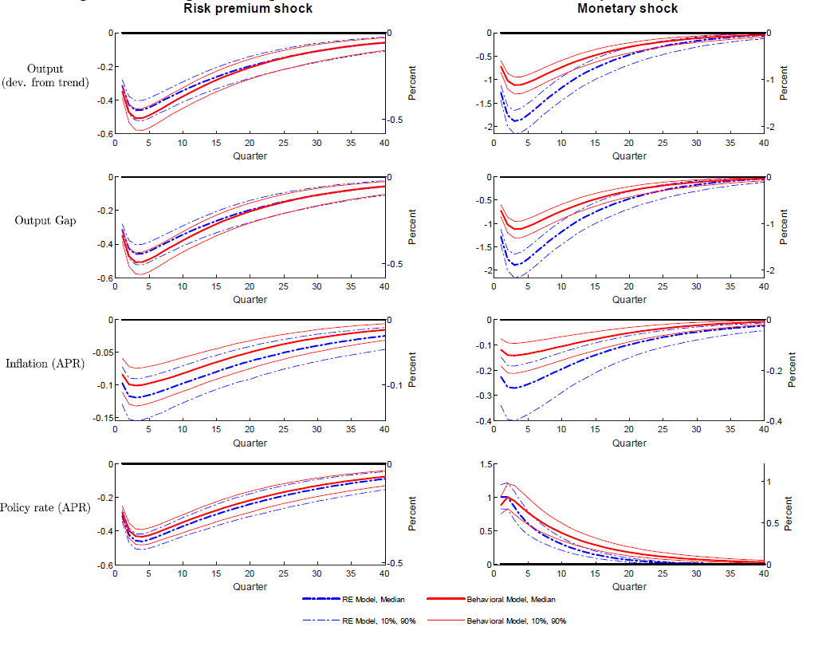
Key Properties of Model: Forward Guidance
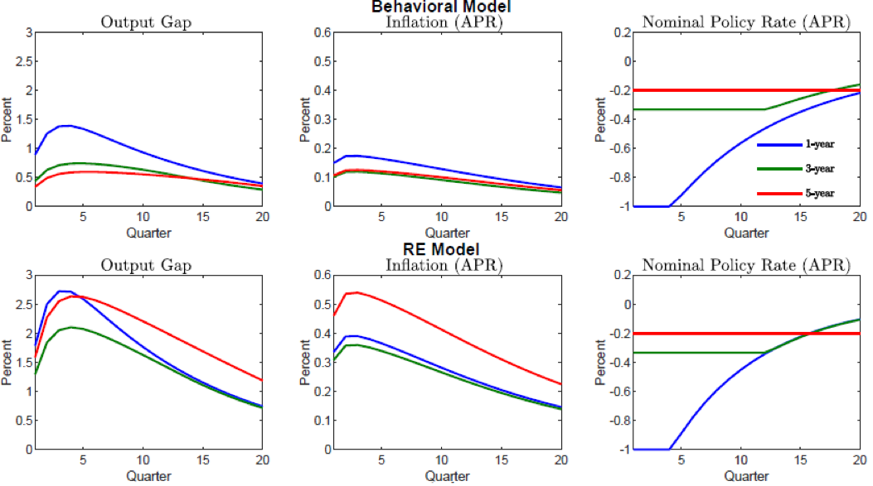

Benefits of UMP
• Use the estimated model to study how UMP (NIRP, FG, and LSAPs) can affect unconditional and conditional distributions.
- Key steady state assumptions: steady state i=2.6, $π^{*}$=2.0, $Δy$=1.2

• Assume ECB more aggressive when $π_{t}$ is expected to be above $π^{*}$:
$$i_{t}=\max_{}\left\{ELB,i_{t}^{*}\right\}$$
it*=1-γii+γππt-π*+γyxxt+γ∆yx∆xt+γπmaxπt+4|t-π*,0+γiit-1+εi,t
where ${\overline{π}}_{t+4|t}$ = $\left(π_{t+4|t}+π_{t+3|t}+π_{t+2|t}+π_{t+1|t}\right)/4$ and xt the output gap.
- Asymmetric term added after estimation (since the inception of the ECB Jan. 1 1999, ${\overline{π}}_{t+4|t}$ has only exceeded $π^{*}$in 6 quarters for the euro area).
- Estimated parameters: $γ_{i}=0.92$, $γ_{π}=1.62$, $γ_{x}=0.16$, $γ_{∆x}=0.19$

Benefits of UMP (Cont.)
• When we allow for UMP tools (NIRP, FG and LSAPs), we change the modeling of monetary policy as follows:
- NIRP: Set ELB=-1 (Annualized reversal rate).
- FG, lower for longer/make-up strategy: Assume CB smooths over shadow rate $i_{t-1}^{*}$ so that policy rate remains at ELB for longer than if CB smooths over $i_{t-1}$. Effective since estimated $γ_{i}$ is large (0.92).
- LSAPs: Endogenous asset purchases:
  - CB initiates asset purchases to offset risk-premium shocks (b) when policy rate falls below ZLB.
  - CB expands asset purchase program as long as ELB binds, but is subject to an upper limit when the risk-shock is fully offset.
  - New asset purchases reduced upon ELB exit and terminated fully when policy rate exceeds ZLB, after which the LSAP program is scaled down gradually (half-life one year).
  - Technical modelling details in paper.
Benefits of UMP (Cont.)
• Simulating the model for the alternative policies:
- “No UMP” – benchmark policy rule subject to a ZLB constraint.
- “NIRP+FG” – ELB = -1 percent and state-dependent forward guidance.
- “UMP” – full Monty with NIRP+FG+LSAPs.
• Notice that we subject the economy to exactly the same exogenous shocks, so all differences in outcomes are driven by policy.
- Use posterior mode (point estimates) to generate an artificial sample of 25,000 observations.
• Report simulations results for both BR and RE models, allow separating out implications of deviating from RE.

Unconditional Distributions: Benchmark “No UMP” case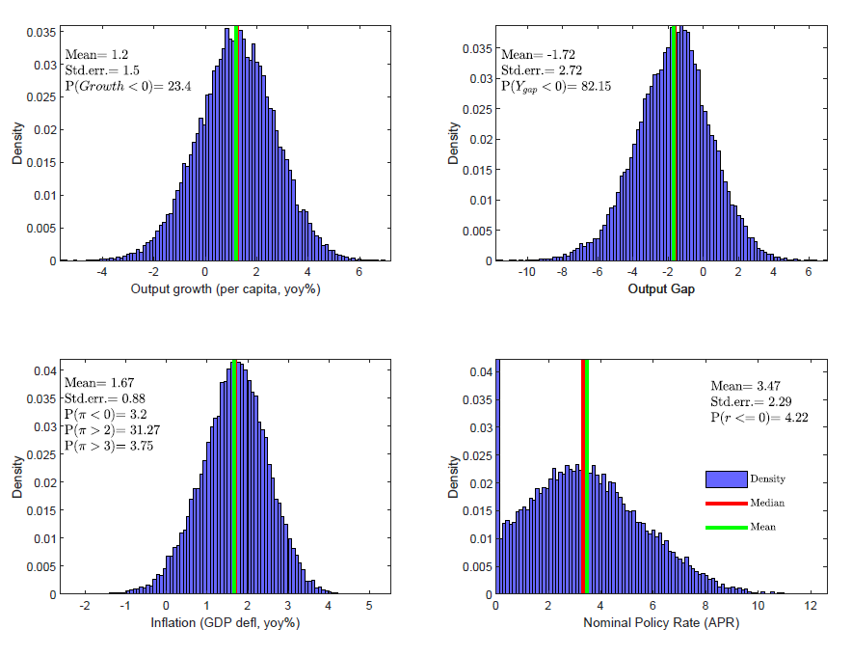
Effects of UMP on Unconditional Distributions
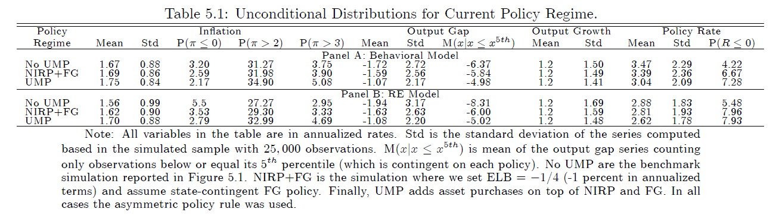
• Key finding: Asymmetric rule/regime generates large output cost which is only partially offset by UMP.
- UMP tools mute the severity of recessions – $M\left(x|x≤x^{5th}\right)$ – average of output gap realizations for 5th percentile.
- Stochastic mean for inflation ¼ percent below target even with UMP.
Effects of UMP on Conditional Distributions
• We now turn to study conditional distributions.
• The conditional distributions are contingent on data up to 2020Q3 (actual data up to 2020Q2, projected data 2020Q3), and then computing a dynamic forecast allowing for shock uncertainty 2020Q4-2025Q2. Three key assumptions:
- Effective term-premium 250 bps (informed by EA corporate spread data).
- Shadow rate -4.60 percent (estimates using Wu and Xia, 2016, method).
- Symmetric rule, drop asymmetric component $γ_{π}\max_{}\left\{{\overline{π}}_{t+4|t}-π^{*},0\right\}$.
• Compare forecast distributions conditional on these policies:
- Baseline sim with EONIA tightened to ZLB and no further UMP – “No UMP”.
- Policy rate cut to ELB and state-dep. FG – “NIRP+FG”.
- NIRP+FG plus setting r∆yy = 0 in the policy rule – “NIRP+FG (r∆yy = 0)”.
- Additional large scale asset purchases to lower borrowing spreads – “UMP”.
Conditional Distributions Given State 2020Q3: Behavioral Model
Conditional Distributions Given State 2020Q3: RE Model
Large Gains from Dropping Output Growth (r∆y = 0) in Rule
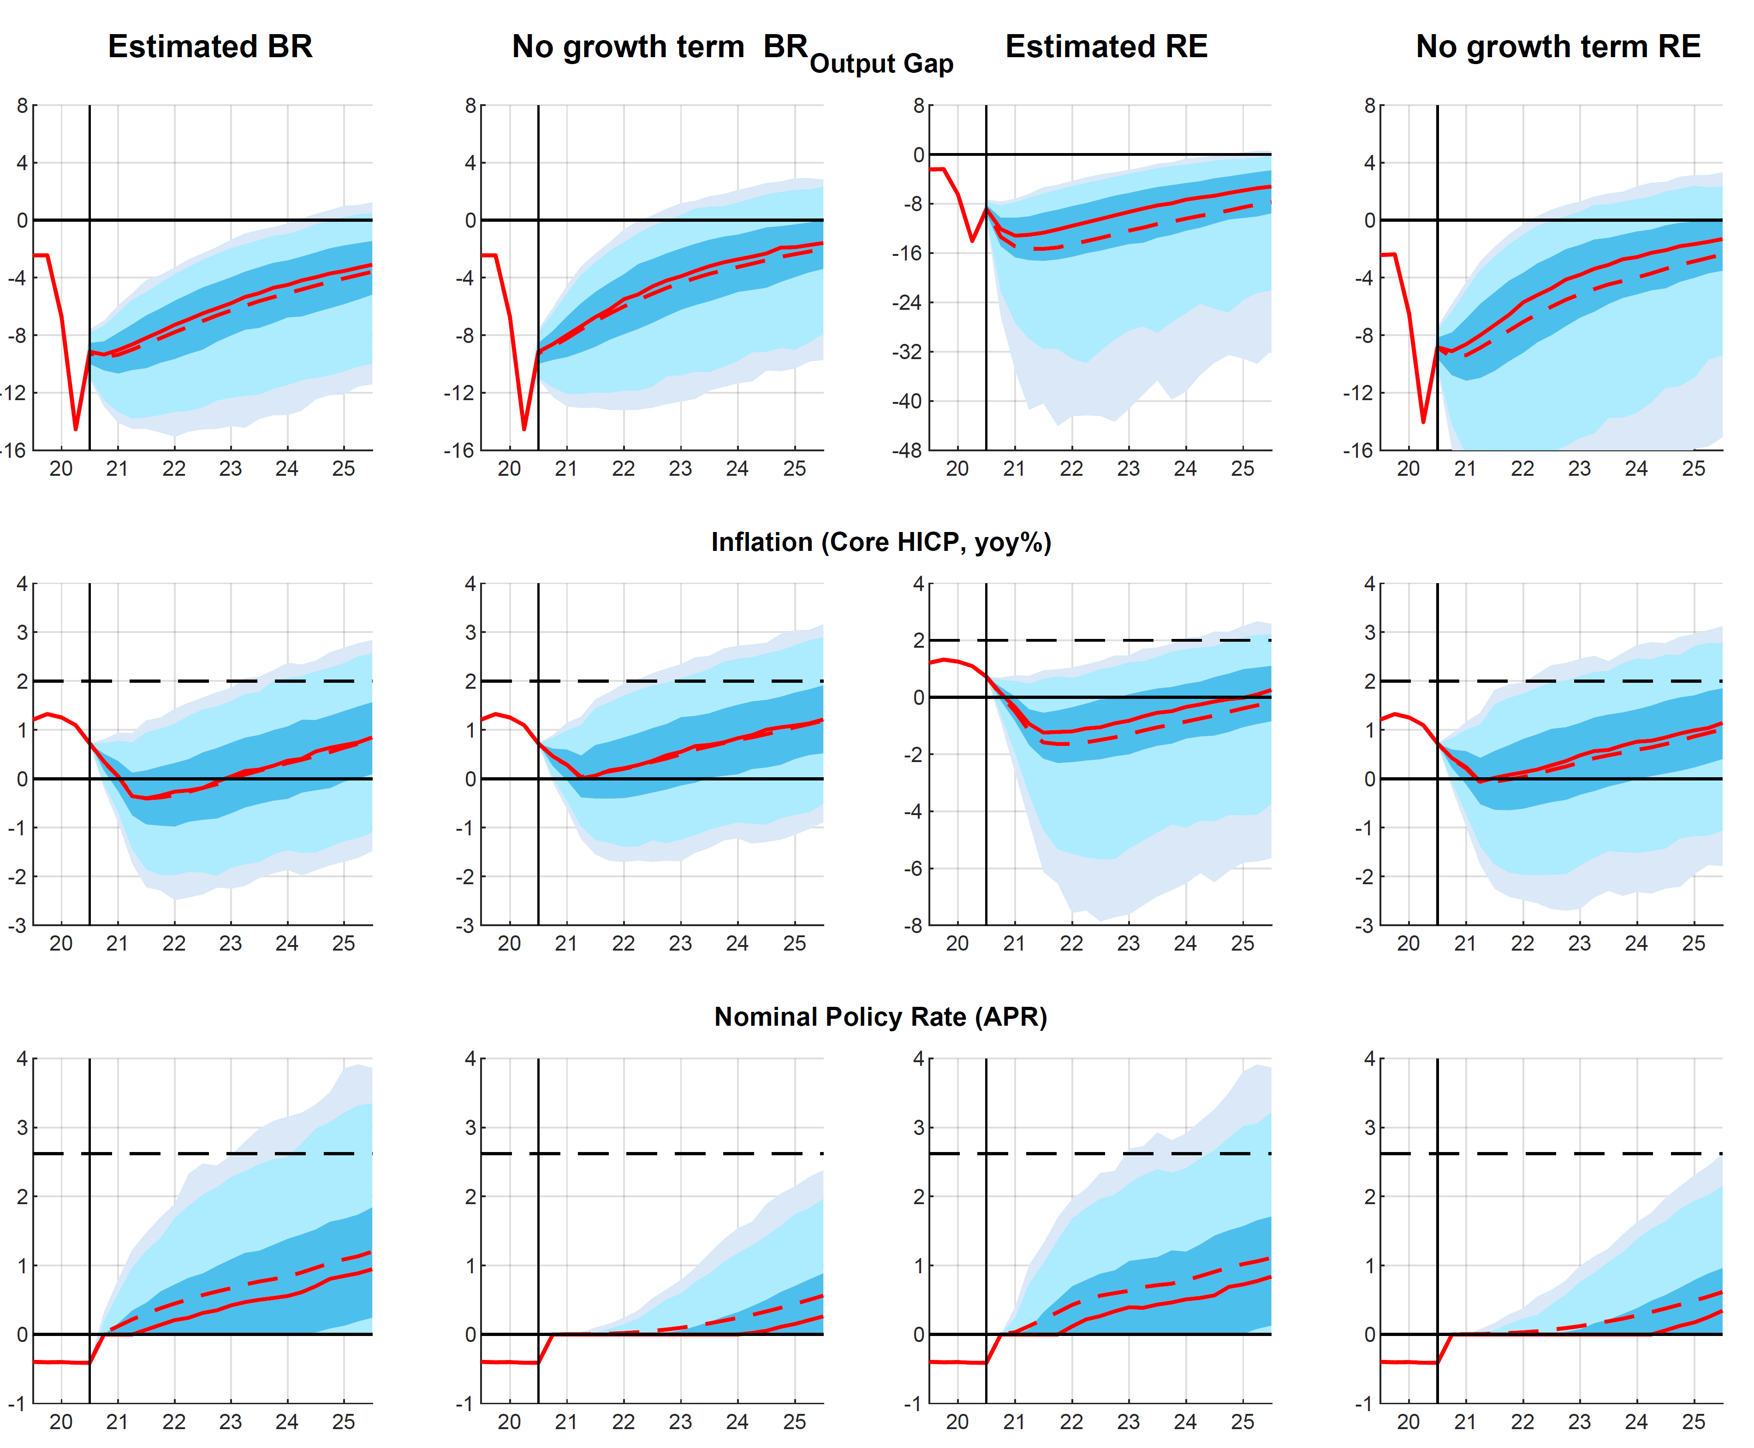
Benefits of New Frameworks
● We now turn to analyze the effects of alternative frameworks.
● Consider the following alternatives:
- Symmetric inflation target, drop term $γ_{π}\max_{}\left\{π_{t}-π^{*},0\right\}$ in the policy rule.
- Symmetric and lower inflation target (1.5 instead of 2 percent).
- Average inflation targeting (AIT) with symmetric rule, CB responds to ${\overline{π}}_{t}-π^{*}=\sum_{s}{π_{t-s}-π^{*}}$ where we set horizon s = 0,…,19 (5 years). Similar features to FG/make up strategies (but focuses on inflation).
- Price level targeting (PLT) with symmetric rule where horizon s = 0,…,$∞$.
- Symmetric 1-3 percent inflation target-band: CB only small reaction to inflation $i_{t}^{}-i=1.01\left(π_{t}^{yoy}-π^{*}\right)$ inside the band, follow estimated rule outside bands.
● Table on next slide show unconditional distributions for the alternative policies when imposing the ZLB (no UMP tools deployed); all contingent on same shocks so fully comparable.

Benefits of New Frameworks: Unconditional Distributions
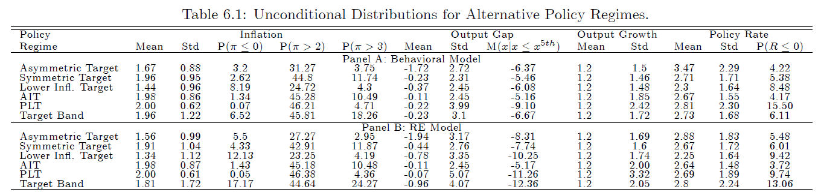
• Three key findings:
- Symmetric target increases average output gap, reduce downward inflation bias, and lower deflation probability.
- A symmetric lower target of 1.5 percent causes a higher output gap and output volatility and larger negative inflation bias relative to a 2 percent target.
- AIT/PLT generate more stable inflation but higher economic volatility (trade-off).
Benefits of New Frameworks: Conditional Distributions
● We now move on to study impact on conditional distributions for alternative strategies.
● Given state in 2020Q3, unexpected but fully credible shift to alternative regime in 2020Q4.
● Consider the following four alternatives:
- Benchmark rule without UMP tools.
- AIT rule; filter initial AIT gap using core HICP for last 5 years.
- AIT rule with larger AIT gap response coeff (5 times $γ_{π}$ estimate).
- PLT rule; filter initial gap using core HICP for last 5 years.
● No UMP (ZLB) to tease out partial impact of alternative frameworks.
- Consider only symmetric regimes (asymmetry matter little anyway given outlook)
- Drop IT band and lower IT regimes (similar to benchmark rule anyway).
Cond. Distributions 2020Q3 for Alt. Policies: BR Model
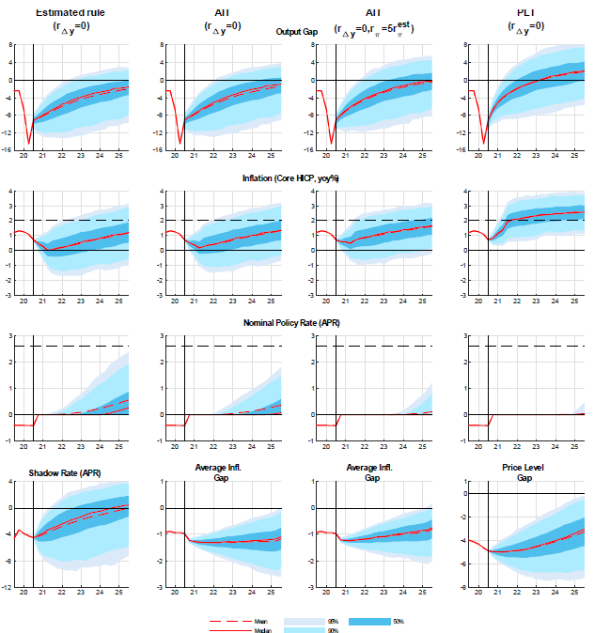

Cond. Distributions 2020Q3 for Alt. Policies: RE Model
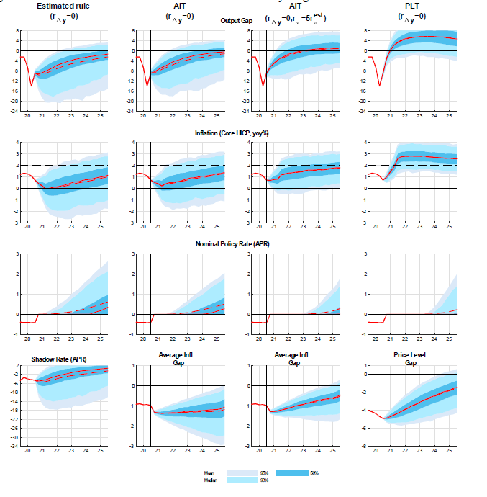

Robustness Analysis
• Examine the robustness of findings in a number of dimensions:
- No markup shocks.
- Behavioral expectations in pricing bloc ($φ^{f}$ estimated to be 0.95).
- Allowing for a state dependent price Phillips curve: Higher slope when output gap is positive and lower slope when there is slack.
- AIT with higher AIT gap response coefficient in the rule.
- Size of steady state real rate ($σ_{c}=0.5$ vs. $σ_{c}=1.25$) in RE Model.
• All results generated subject to ZLB constraint; no UMP tools deployed.
• Find that key results are robust w.r.t. alternative assumptions.

Robustness Analysis: Unconditional Distributions
• Key findings for cost-push shocks and Dev from RE in Pricing Bloc:
- Cost-Push shocks account for sizeable share of output cost of an asymmetric target, about half of inflation bias.
- Deviations from RE in pricing bloc further boosts costs of asymmetric target. Shorter planning horizon effectively reduces the ability of the CB to control inflation through expectation channel.
Robustness Analysis: Unconditional Distributions II
• Key findings for state dependent slope of Price Phillips Curve (BR Model):
- Under asymmetric target, state dependent pricing somewhat amplifies output cost but reduce inflation bias (tradeoff).
- Symmetric target leads to a slight positive inflation bias (since state dependence pricing function is convex).

Robustness Analysis: Unconditional Distributions III
• Key findings for AIT response coefficient:
- Stronger response on AIT gap in rule => lower inflation volatility.
- Stronger response on AIT gap in rule => higher output volatility.
- True in both BR and RE variants of model.

Rob. Analysis: Cond Distributions for Full BR Model
Robustness Analysis: Comparing Alternative Models
● Behavioral expectations for households only; RE for firms and LUs. Sizeable gains.
Estimated Rule (symmetric) AIT AIT - large AIT gap coeff PLT
● Behavioral expectations for all agents in the model. Notably smaller gains.

Conclusions
● UMP cannot fully offset adverse effects of an asymmetric target in a low rate environment.
- Large conditional gains and small unconditional losses from reducing role of output growth in the conduct of monetary policy (focus more on gap instead).
● Sizeable gains of moving to a symmetric target.
- Asymmetric target associated with large negative mean output gap and downward inflation bias – a finding driven by a flat Phillips curve and important role for trade-off (cost-push) shocks.
- Findings support recent move towards symmetric interpretation of target.
● No evident gains with a lower inflation target.
- A symmetric target of 1.5 percent causes higher output volatility and larger negative inflation bias relative to a 2 percent target.
● AIT/PLT strategies favorable conditional short-term properties (exactly how large depends importantly on expectational effects), but may be costly unconditionally (i.e. long-term).
Future Extensions
● Future work: Useful to extend our work in a number of dimensions:
(a) Adopt a loss function-based approach (see Svensson, 2010, 2018).
(b) Implications of alternative ways to address the FG puzzle.
(c) How active fiscal policy can provide support when MP is constrained.

