What Makes Local Governments More Accountable?

Evidence from a Website Reform

Presentation to the

Chinese Economy Working Group - NBER

Cambridge, MA

September 26, 2019

Daniel Berkowitz, University of Pittsburgh; Yi Lu, Tsinghua

University, and Mingqin Wu; South China Normal University

Local Governments in Many Countries

Responsible for investing in education, infrastructure, health services, welfare, etc

There is a real concern, however, that many use their position in order to collect bribes and build local empires

How corrupt are local governments?

What pushes local governments to be corrupt or to accountable to their constituents?

Comparative Economics

Brazil compared to China

- Ferraz and Finan (2012) measure local government corruption in Brazil using results from a randomized survey

- They show that the local voting system drives corruption: mayors in their second term cannot run for re-election and they misappropriate $55,000 per year in resources more than mayors who can run for re-election

- When there is an active radio station and/or newspaper reporting on a municipality then the greater corruption coming from mayors in their second term vanishes driven by re-election incentives vanish
China versus Brazil

- In China, voting and free press are much weaker than in Brazil

- What to do about absence of voting for local governments in China? => Substitute re-election incentives operating in Brazil with promotion incentives

- What to about absence of radio stations and newspapers that freely monitor local governments? => Substitute the free media in Brazil with social media

To do this, we exploit a massive policy experiment enacted by the national government during the last years of the Hu Jintao and Wen Jiabao Leadership and that remained in force under Xi
County Website Reform

In 2011 National Government orders its 32 provincial level governments to pick 3-4 counties for a policy in which they are required to post their data on their websites

Treated counties are required to set up links on their websites enabling their constituents to send inquiries and grievances to their county govt which is expected to respond in a timely fashion.

In January 2012, program is enacted in 100 of China’s roughly 2800 counties

Treated counties post their data; some counties set up online forums for their citizen attach a Sina Weibo link

Figure 1. Spatial Distribution of Treated Counties
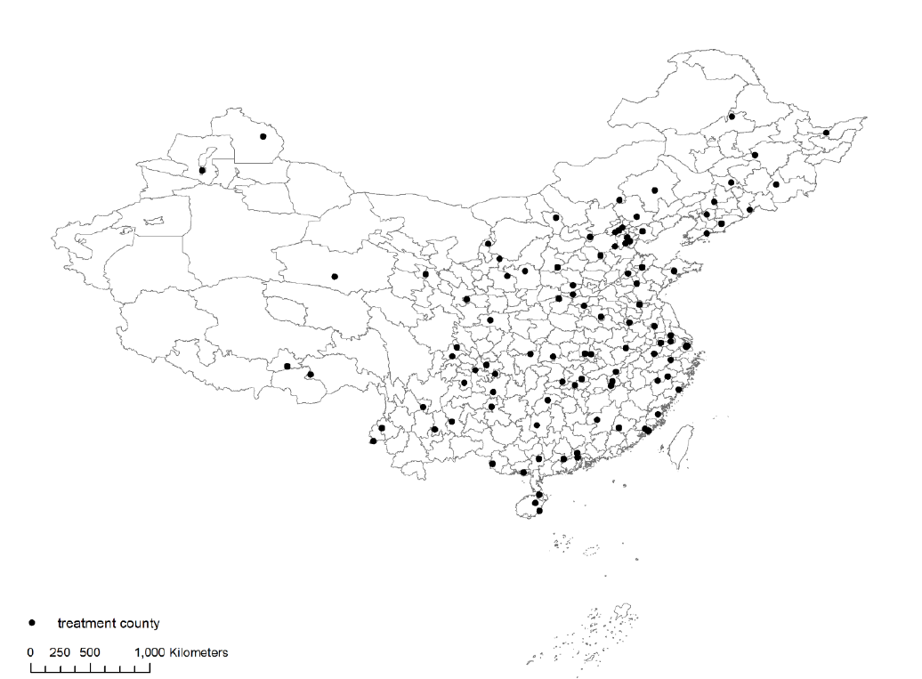

Experimental Design and Data

Provincial governments are required to select counties that have the best existing websites, best public finances, etc => Treatment is not randomly assigned.

Use quasi-experimental design using methods from Gentzkow (2006) so that assignment is close to being as good as random

All treated counties comply – No issues of “intention to treat”

General Idea of the Study

- In China local officials want to be promoted up to the prefectural, provincial or national level

- Getting promoted is TOUGH and it depends upon how your overseeing government (provincial) values your performance which includes the economic output and social harmony in your county and also lack of corruption

- Traditionally overseeing governments depended upon bureaucratic agencies to provide information about the performance of their local governments

- In China and, in many autocracies around the world, overseeing governments now use comments from private citizens in order to evaluate local governments.

- Website reform gives citizens living in treated counties more information and more access to their county government

- they can post more informed grievances and inquiries on social media which the overseeing government can use for evaluating and making promotion decisions for the leaders of the county government under its jurisdiction

- County level governments have an incentive to be less corrupt and to make better investment (a bit subtle)
Webpage, Shunde district, Guangdong
Province, Dec 21, 2012

Transparency Link

Online Service Link

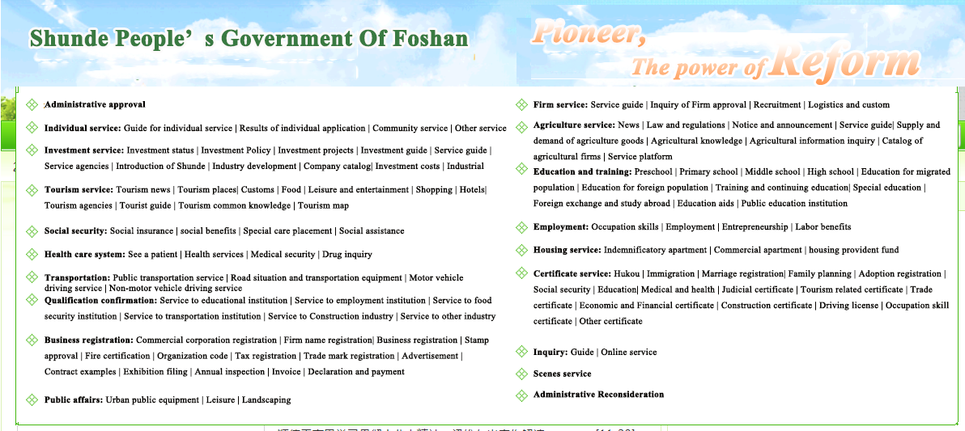

Interaction Links Between County Government and Citizens

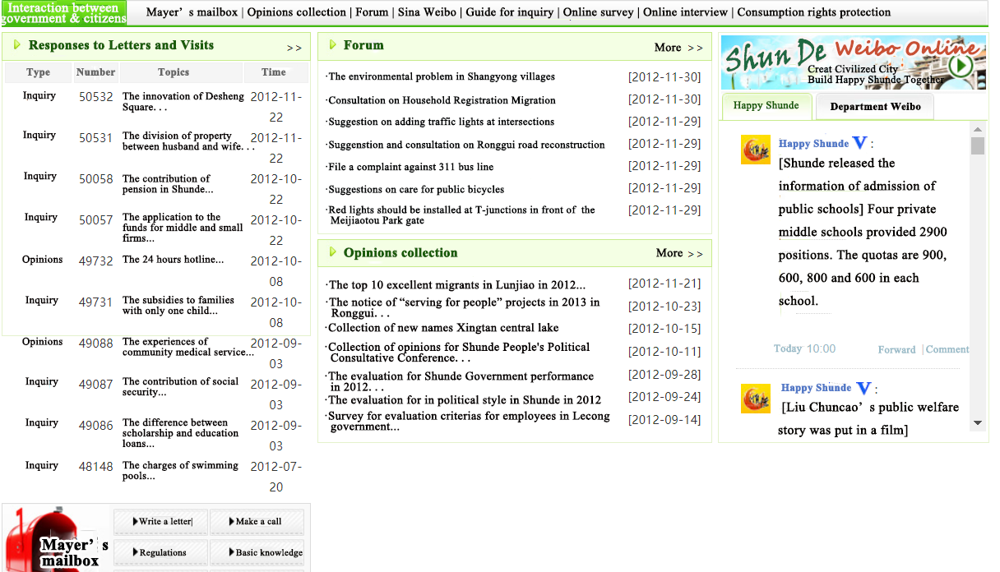

Citizen Communications with Government

Shunde district: citizens use online forum to complain about poor quality of classrooms and medical services.
And, government responds using the online forum.

Shunde - Massive increase of clicks of online forum 460,000 in 2009 to 2.6 million in 2012 and 4.6 million in 2014

Not all counties have online forums;

But, all have transparency links and Sina-Weibo links

More Information from Government and More Citizen Communication

In treated versus control counties, there is a 22% increase in links on county webpages post-treatment. This is more is than 1/4th of a sample standard deviation!

On Sina-Weibo, there is a massive tweet storm in treated versus control counties post-treatment of words suggesting that citizens are increasing their monitoring of their county governments

We pick 14 key words related to corruption and 14 key word government investment

Corruption: key words all increase and 13/14 all increases are significant at the 5-percent level

Some notable examples

Govt service – 19.5%

Corruption – 12%

Govt openness – 28%

Transparency – 14%

Monitoring – 22%

Investment: all key words increase and, these increases are significant at the 5-percent level

Highways – 26%

Railways – 16%

Airports – 37%

Power grid – 12%

Sentiment Analysis: Positive discussion of a keyword as a share of total discussion (including neutral and negative) of keywords on Sina-Weibo.

Some big effects!

Government service – up by more than 1/2 a sample std. dev.

Transparency - increases by more than a sample std. dev

Corruption, Anti-Corruption and Collusion – increases by almost a 1/3rd of a sample std. dev.

Fixed Investment – no substantial change

.
Is Social Media Credible???

King, Pan and Robert (APSR, 2017) – Regime has 50c users make private postings on regime’s behalf on social media. => Regime could orchestrate content of social media postings

King et al– 50c users follow a general strategy:

- Make comments that “cheerlead” the regime and distract from events that can increase social stability, for example, the “Urumqi Rail Explosion” or “Martyr’s Day;”

- Do not have 50c users to attack or to promote party or government leaders

Is Social Media Believable?

A priori, we do not think that the website reform presents a substantial threat to social stability

A concern is that county leaders would have their friends say great things about their performance so that they get promoted. However, King et al (2017) do not predict such behavior.

Suppose that local government officials have their friends say nice things about them on social media. Would this activity necessarily increase post-treatment in treated counties???

On-going work – Collecting government posts on Sina Weibo post for governments where it is easier to order users to cheerlead and say great things about the county regime.

Model for Empirical Work

Monitoring

π_{mg} = exogenous probability that government overseeing the county government detects G

π_{mr} = exogenous probability that government overseeing the county government detects R

Reform causes in increase π_{mg} and in π_{mr}

=> Model explores comparative statics of π_{mg} and π_{mr}

Promotion Incentives

Investments, G, raise promotion prospects

Rent seeking, R, lower promotion prospects

G = G(R,…), where

G’ ≤ 0: rent seeking is inefficient

G’ > 0: rent seeking greases the wheels

π_{P}(G) = probability of promotion if G is observed:

π’_{P} > 0, π’_{P} ≤ 0

π_{D}(R) = probability that of not being promoted if R is observed:

π’_{d} > 0, π’’_{d} ≥ 0

- The probability of promotion, PP, depends on R:

PP(R) = π_{mg}π_{P}(G(R)) - π_{mr}π_{d}(R)

County leader’s objective function

χ = penalty per unit when a rent seeking county leader gets caught

(1 - π_{mr}χ)R = expected personal benefit to a county leader from rent seeking, where 1 > π_{mr}χ > 0

U^{P} = utility of a promotion

U^{L} = 0 = utility of not being promoted

Demotions are rare and ignored for simplicity

County leader chooses R>0 in order to maximize

PP(G(R), R)* U^{P} + (1 - π_{mr}χ)R

Predictions (for R*>0)

Prediction 1. If G’ < 0: rent seeking is inefficient, then more transparency (π_{mg} and/or π_{mr} increase) causes R to decline; and G to increase.
Prediction 2. If G’ > 0: rent seeking greases the wheel, then the impact of more transparency is ambiguous. If the increase in π_{mr} is stronger than π_{mg}, the both R and G increase; however, if the increase in π_{mg} is stronger than π_{mr}, both R and G decline.

FINDINGS ARE CONSISTENT WITH A WORLD WHERE G’ < 0 and rent seeking does not grease the wheel

Prediction 3. If G’ < 0, then an increase in transparency generally causes promotions of county leaders to increase

Prediction 4. If If G’ < 0, then impact of reform on R and G is stronger the further is a county from its overseeing government

Estimated Impact of Reform on Corruption

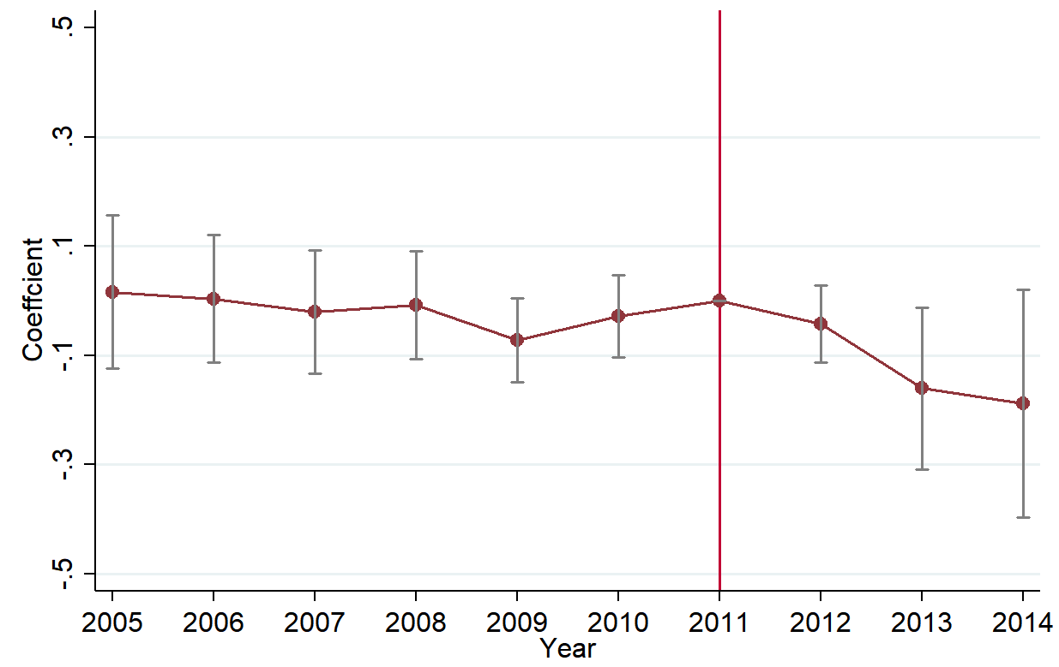

Notes: The points represent coefficients of treatment interacted with Year Dummies. The default year is 2011. The dependent variable is Corruption.

Corruption Measured with Business Expenses

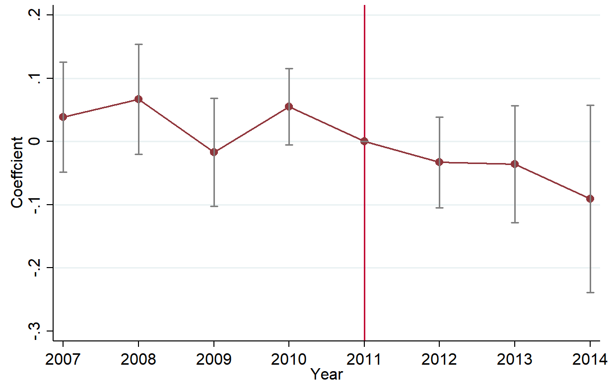

Corruption Measured with Land Sales
(Share of Open versus Closed Transactions)

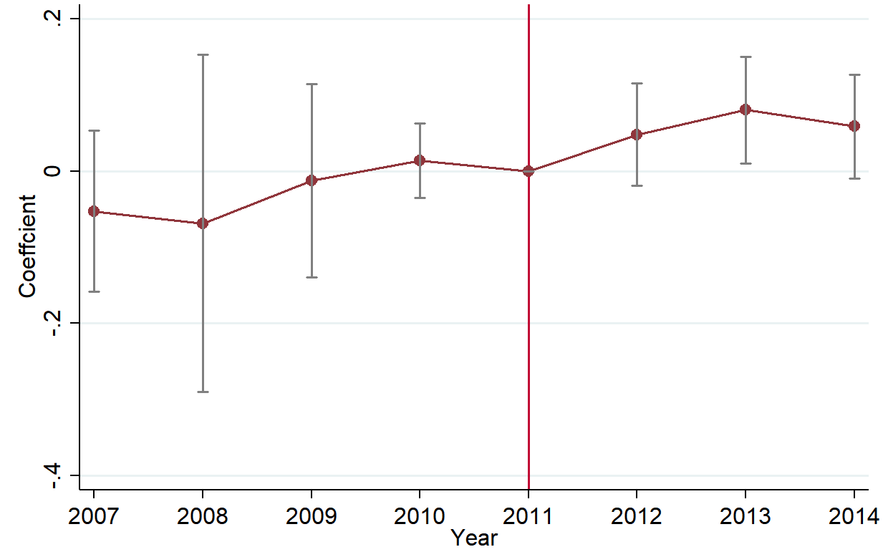

Impact of reform on public investment

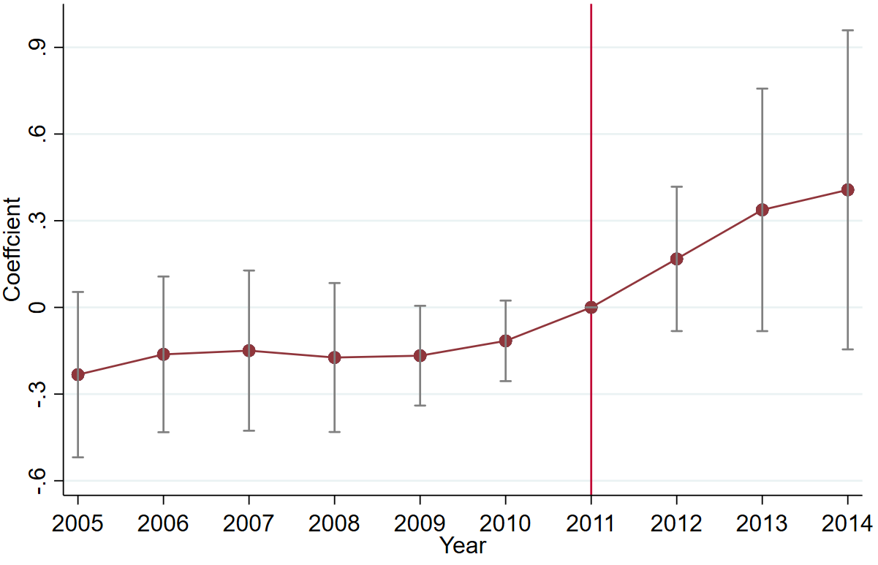

CONCERN – do investments promote social welfare and growth? Are they white elephants? Public image investments? Will can deal with this indirectly

Satellite data shows nighttime lights increase– suggests that investment enhances social well being

Public sentiment data – indicates constituents are more satisfied with public services

Public image data – there is no much discussion of this pre-treatment and a negligible decline post-treatment in treated counties

Impact of reform on promotions
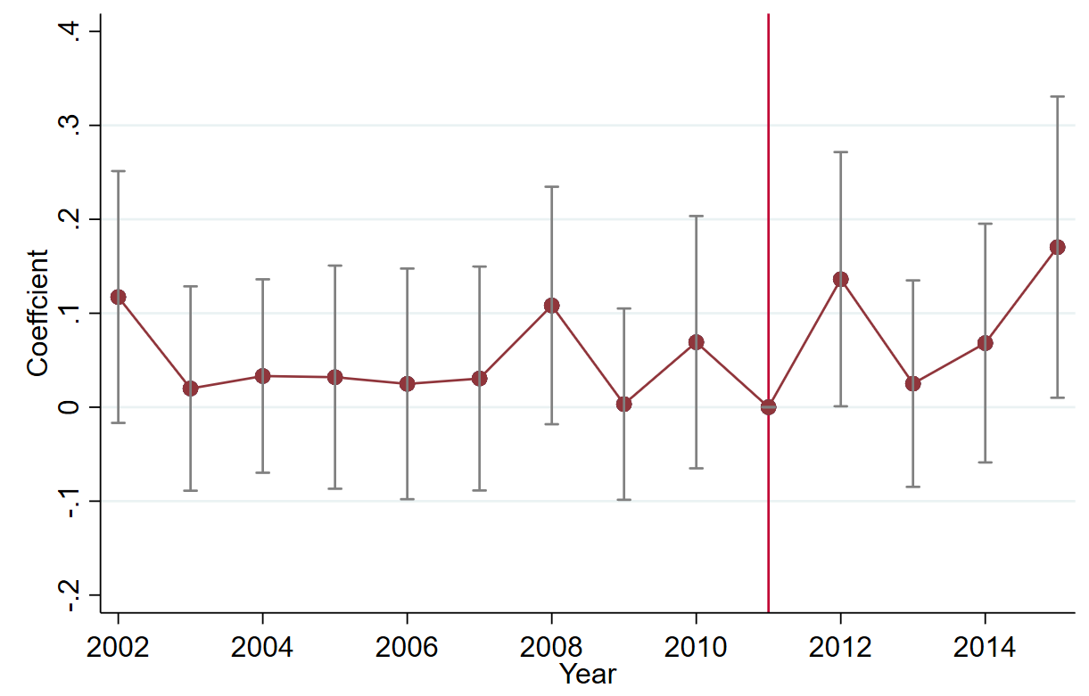

Conclusions

Online social media operates gives voice to constituents.

However, social media does not allow for substantially more citizen participation in politics and, thus, is not a substitute for a free press and voting.

Website increase citizen monitoring, and, therefore lowers government corruption and increases investments

Cut in corruption and increase investment and promotions of county party secretaries in treated versus control counties suggests that rent-seeking does not grease the wheels

