Online Appendix for
“Occupy Government: Democracy and the Dynamics of Personnel Decisions and Public Finances”

Klenio Barbosa
Insper Institute of Education and Research

Fernando Ferreira
The Wharton School, University of Pennsylvania, & NBER

Table A1: Summary Statistics of the Party Affiliation and RAIS Matching
 | Mean | SD | Min. | Median | Max. | No.
 | (1) | (2) | (3) | (4) | (5) | (6)
Number: Matched at STEP I | 167 | 486 | 0.000 | 89.0 | 29,437 | 100,464
Number: Matched at STEP II | 8.4 | 34.7 | 0.000 | 4.0 | 2,720
Number: Matched at STEP III | 3.6 | 13.6 | 0.000 | 1.0 | 641
Number: Matched at STEP IV | 5.2 | 26.6 | 0.000 | 2.0 | 1,912
Number: Matched at STEP V | 0.7 | 3.4 | 0.000 | 0.0 | 150
Notes: This table presents descriptive statistics for matching party affiliation with RAIS employer-employee data. Party affiliation observations are collapsed down to the municipality-year level and ranges from 1995-2013. Column (6) shows the number of municipality-year units used in the calculation. RAIS employment data and party affiliation data are merged by individual name. In STEP 1, observations are matched by exact full name. STEP 2 uses the ''soundex'' code of the middle names; that is, matched observations have first, middle, and/or last names with the identical first letter and remaining consonants that sound similar. In STEP 3, each middle name is converted to initial letter (e.g. ''Oliveira'' to ''O'') and then names are matched in the loop of each middle name. In STEP 4, all preposition middle names (e.g. ''Da'', ''De'') are eliminated and the names are matched. In STEP 5, all preposition middle names are eliminated, each middle name is converted to initial letter, and then names are matched.

Figure A1: Distribution of Vote Share for Coalitions
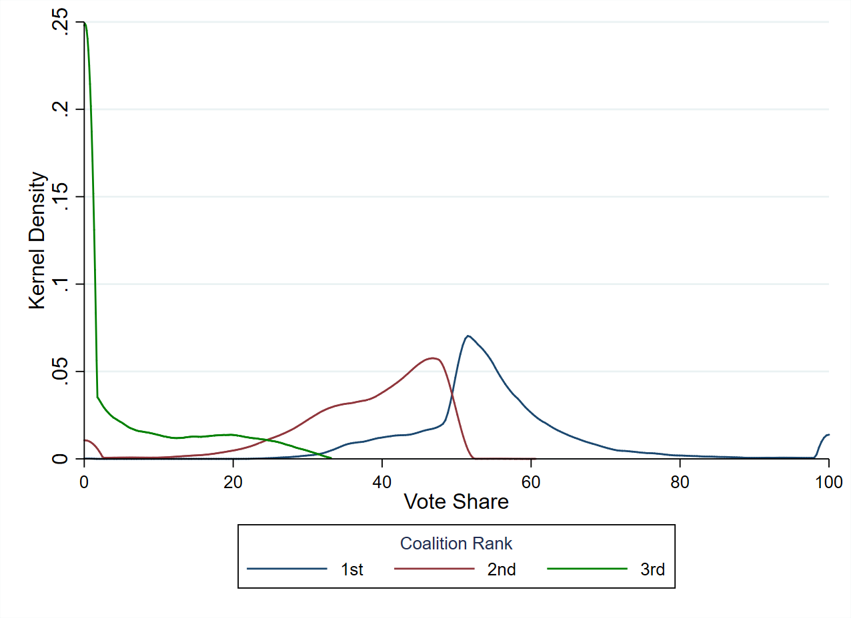

Empirical Strategy to Estimate the Casual Effect of FPM Transfer on Political Personnel Decisions

In this supplementary material, we describe the method that we use to estimate the casual effect of transfer on municipality employment of elected party members by exploring discontinuity changes in federal transfers (FPM) to municipalities at given population thresholds. We first present the institutional framework behind the allocation of transfers from the federal government to Brazilian municipalities, and then we describe the regression discontinuity design that allows us to estimate the effect of transfers on municipality employment of elected party members. The main results are described in Section 6.1 of the paper.

FPM Transfers and Fuzzy RDD Identification Strategy

Fundo de Participação dos Municipios (FPM) is the largest program of transfers to municipalities accounting for almost 80% of all types of federal transfers and 31% of municipal revenues. The FPM was introduced in 1965 as a constitutional amendment by the military government to distribute resources in an orderly and transparent fashion, aiming to weaken local political elites. The FPM funds allocation rule was established in 1981 (decree 1881) and was rectified by the Federal Constitution of 1988. Since then, no changes happened in the FPM transfer allocation rule.
Every year, FPM funds are allocated to municipalities according to a predetermined allocation rule that relies on local population estimates and the state which the municipality belongs to. First, a fixed share of total FPM funds is assigned to each of the 26 states. Second, each municipality is assigned a coefficient which depends on pre-specified population brackets to which a municipality belongs to. Let ${FPM}_{i,t}^{k}$ be the federal transfers received by municipality i in state k in a given year t. The FPM funds allocated to the municipality i in state k in a given year t are determined by the following rule:
${FPM}_{i,k,t}={FPM}_{k,t}\frac{λ(P_{i,t-1})}{\sum_{i∈k}{λ(P_{i,t-1})}}$, (S1)

where ${FPM}_{k,t}$ is the amount of (fixed) resources allocated to state k in given year t. The parameter $λ(P_{i,t-1})$is a step-wise function of estimated local population in the previous year ($P_{i,t-1}$). It represents the FPM coefficient of municipality i. FPMs;t = sFPMt is equal to the share of total resources ${FPM}_{t}$ in a given year t. The fraction $\frac{λ(P_{i,t-1})}{\sum_{i∈k}{λ(P_{i,t-1})}}$ is simply the share of ${FPM}_{k,t}$ that goes to municipality i in state k in a given year t. This rule applies to all municipalities that are not state capitals and have less than 142,633 inhabitants
The FPM coefficients are based on yearly population estimates produced by the federal statistical agency, IBGE - Instituto Brasileiro de Geografia e Estatistica (Brazilian Institute of Geography and Statistics) - and supervised by a federal court. IBGE calculates municipal population for non-census years taking into consideration past censuses, regional birth and death rates, migration trends and other features using a publicly known methodology. Population estimates for year t are announced by October 31st. On this basis the Federal Budget Court publishes the FPM coefficients for all municipalities. Then local authorities form the budget for fiscal year t. The budget is approved by municipal councils by the end of the year and FPM funds are transferred during year t. TableS.2 presents FPM coefficients ($λ$) at various population brackets and the thresholds.
There are two important features of the FPM transfer allocation rule. First, municipalities in the same bracket (in a given year and state) should get the exact same amount of transfers, independently of the exact number of inhabitants. Second, federal transfers change discontinuously at the cutoffs. Note that, according to the FPM transfers allocation rule in Table S.2, the probability of a higher FPM transfers increases discontinuously when the municipal population reaches the cutoff. Figure S.2 plot the log of the actual total and per capita FPM transfers averaged over inhabitants’ bins around the pooled cutoffs (population size minus nearest thresholds). There is clear evidence that the law shaping FPM transfers discontinuity do change at given population thresholds.

RDD validity
Our RD design relies on two main identifying assumptions: (ii) other sources of municipal revenues and no other relevant for municipal covariates do not change around the FPM thresholds, and (ii) if municipalities do have perfect control over their population size. In this subsection we show that those assumption hold.
We empirically investigate whether municipality covariates discontinuity changes at the FPM population, and we do not find municipalities moving to an adjacent FPM population bracket are similar to those that do not cross the cutoffs across many characteristics, including demographics, tax revenue and transfers, and political economy features (political alignment of the mayor and councilors to the federal government, political competition, and mayoral terms). The results are available upon request.
RD design strategies rely on the assumption that if municipalities do not have perfect control over the running variable (population), this implies that variation in treatment status (i.e., be above or below the FPM cutoffs) will be randomized in a neighborhood of the threshold. If municipalities do have perfect control over their population size, then one should observe around the cutoff zero a relatively large number of municipalities on the right-side of the population cutoffs, and only a few on the left-side. That would lead therefore to a discontinuity of the density of the margins of votes at the threshold zero (normalized cutoff). We examine whether the density of population is continuous at the cutoffs. McCrary density plots uncover pooling of municipalities on right side of the discontinuity. Those results indicate the identification assumption for RDD holds. McCrary tests are available upon request.

FPM Results

To estimate the effect of transfers on municipality employment of elected party members, we augmented the econometric model described in equation (5) to account for the discontinuous changes in federal transfers (FPM) to municipalities at given population thresholds by including an interaction effect with the winning coalition at the population threshold, and controlling population threshold and for a third-order polynomial of the population size. The results are described in Section 6.1 of the paper.

Table A2: Population Brackets, FPM Coefficients and Thresholds

Population Brackets | FPM Coefficients | Thresholds
Below 10,188 inhabitants | 0.6 | 10,188
Between 10,189 and 13,584 inhabitants | 0.8 | 13,584
Between 13,585 and 16,980 inhabitants | 1.0 | 16,980
Between 16,981 and 23,772 inhabitants | 1.2 | 23,772
Between 23,773 and 30,564 inhabitants | 1.4 | 30,564
Between 30,565 and 37,356 inhabitants | 1.6 | 37,356
Between 37,357 and 44,148 inhabitants | 1.8 | 44,148
Between 44,149 and 50,940 inhabitants | 2.0 | 50,940
Between 50,941 and 61,128 inhabitants | 2.2 | 61,128
Between 61,129 and 71,316 inhabitants | 2.4 | 71,316
Between 71,317 and 81,504 inhabitants | 2.6 | 81,504
Between 81,505 and 91,692 inhabitants | 2.8 | 91,692
Between 91,693 and 101,880 inhabitants | 3.0 | 101,880
Between 101,881 and 115,464 inhabitants | 3.2 | 115,464
Between 115,465 and 129,048 inhabitants | 3.4 | 129,048
Between 129,049 and 142,632 inhabitants | 3.6 | 142,632
Between 142,633 and 156,216 inhabitants | 3.8 | 156,216
Above 156,217 inhabitants | 4.0 | -
Notes: This table presents the FPM coefficients (λ) at various population brackets that are used to compute the FPM transfer received by each municipality according to equation (S1).

Figure A2 – FPM Transfer and Per Capita FPM Around the Pooled Cutoffs

