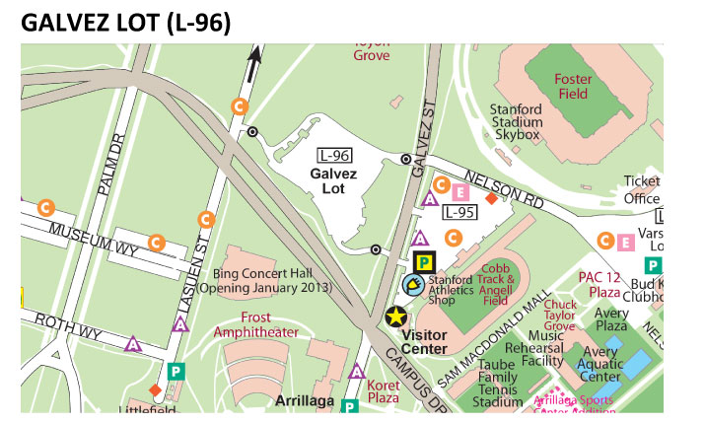
The code for attendees to pay $8.00ea. upon arrival on 10/25/13 is: 3709. The map above shows where the 3 entrances to the lot are located (marked with a black target).
Payment options: Visa/Mastercard or exact Cash and Coins.
Here are instructions on how to use the machines:
1. First park and remember your space number
2. Touch any key to wake the machine if asleep
3. Enter your space number
4. Select Daily or Incremental Option (incremental rate is only available after 9am, before 9am daily rate is the only option)
5. Select “Yes” when it asks if you have a coupon
6. Enter the Coupon Number (3709) and press OK
7. Once the code is entered, you’ll receive a message that says “Get Ready For Payment”
8. Insert your Visa/Mastercard or cash payment (if incremental rate was selected and paying by credit card, increase the expiration time by pressing the ‘1’ key). If paying by cash, depositing more money increases the expiration time
9. Select OK to complete transaction and print your receipt. No need to display receipt on dashboard

Note: On Saturday, attendees can park in the Galvez Lot, or even closer to the building, there is parking on Memorial Way & Galvez Drive that is free on weekends. Any 'A', 'C' or 'Visitor' parking spaces are free to park on weekends.

